

Department of Electrical and Computer Engineering

Second semester 2022

Digital lab ENCS2110

Experiment No. 3 - Encoders, Decoders, Multiplexers and Demultiplexers

Khalid sami

1193137

## Abstract :

The aim of the experiment is to learn about the functionality of Encoders, Decoders, Multiplexers and Demultiplexers and how to implement functions using them.

Table of Contents

Abstract : 2

Theory : 4

Encoders : 4

Fig (1) : 4 to 2 encoder 4

Fig (2) : Basic Encoder 5

Decoders : 5

Fig (3) : 2x4 decoder 5

Fig (4) : 2x4 decoder from basic gates 6

Multiplexers : 6

Fig (5) : 4x1 MUX 6

Fig (6) : 4x1 MUX with basic gates 7

Demultiplexers : 7

Fig (7) : 1x4 Demux 7

Fig (8) : 1x4 Demux with basic gates. 8

Procedure : 8

4-to-2-Line Encoder with Basic Gates : 8

Fig (9) : 4-to-2-Line Encoder with Basic Gates 8

Truth table (1) : 4-to-2-Line Encoder 9

9-to-4-Line Encoder with TTL IC : 9

Fig (10) : 9-to-4-Line Encoder 9

Truth table (2) : 9-to-4-Line Encoder . 10

2-to-4 Line Decoder with Basic Gates : 10

Fig (11) : 2-to-4 Line Decoder 10

Truth Table (3) : 2-to-4 Line Decoder 11

4-to-10 Line Decoder with TTL IC : 11

Fig (12) : 4-to-10 Line Decoder 11

Truth Table (4) : 4-to-10 Line Decoder 11

2-to-1 Line Multiplexer with basic Gates : 12

Fig (13) : 2-to-1 Line Multiplexer 12

Truth Table (5) : 2-to-1 Line Multiplexer 12

8-to-1 Line Multiplexer with IC : 13

Fig (14) : 8-to-1 Line Multiplexer. 13

Truth Table (6) : 8-to-1 Line Multiplexer with IC 13

Given the following function: 13

F(A, B, C, D)=Σ(0,2,4,5,7,8,10,11,15) 13

Truth Table (7) : 3.7 function implementation 14

1-to-8-Line Demultiplexer with CMOSIC : 14

Fig (16) : 1-to-8-Line Demultiplexer with CMOSIC 14

Truth Table (8) : 1-to-8-Line Demultiplexer. 15

Conclusion : 16

References: 17

# Theory :

## Encoders :

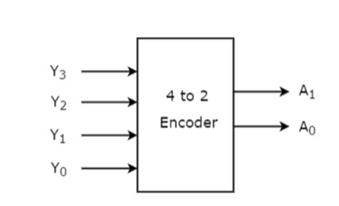

### Fig (1) : 4 to 2 encoder

*) The Encoder is a combinational circuit that has an input of 2n and an output of n. The output

describes the value of the inputs in binary. For example, if the Encoder input was (0100) where

the left is the most significant bit and right is the least significant bit the output will be (10). In

the same way if the input is (1000) the output will be (11). Figure 2 shows the basic circuit of

the Encoder.

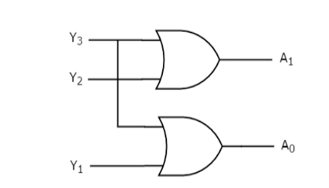

### Fig (2) : Basic Encoder

## Decoders :

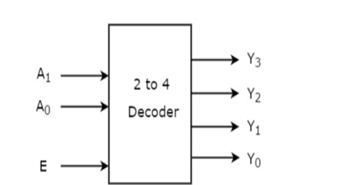

### Fig (3) : 2x4 decoder

*) The Decoder is a combinational circuit that has an input of n and an output of 2n

. only one

output will be turned on depending on the inputs. For example if the input is (10) the output will

be (0100) where the left is the most significant bit and right is the least significant bit. The

decoder only works when the enable input is turned on. Figure4 shows the basic circuit of the

Decoder.

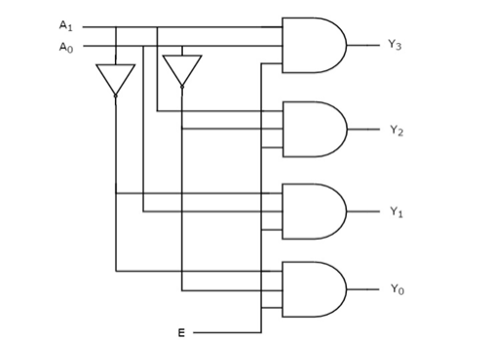

### Fig (4) : 2x4 decoder from basic gates

# Multiplexers :

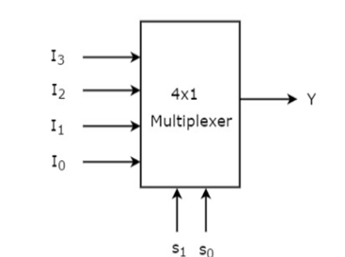

### Fig (5) : 4x1 MUX

*) Multiplexers are a combinational circuit that has an input of 2n and a selection line of n and

only one output. The output depends on the selection line that chose a specific input. For

example if the selection lines value is (11) the output will be (Y3). Figure6 shows the circuit of

the 4x1 multiplexer

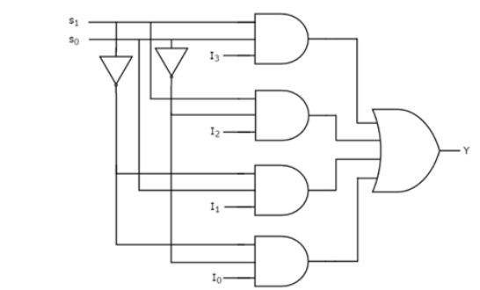

### Fig (6) : 4x1 MUX with basic gates

## Demultiplexers :

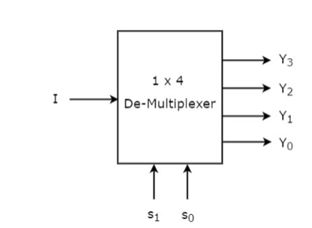

### Fig (7) : 1x4 Demux

*) The Demultiplexer is a combinational circuit that has only one input and n selection lines and

an output of 2n. The output depends on the selection line for example if the selection line value is

1. the output (Y1) will be turned on.

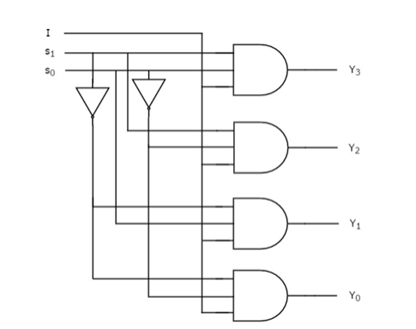

## Fig (8) : 1x4 Demux with basic gates.

# Procedure :

## 4-to-2-Line Encoder with Basic Gates :

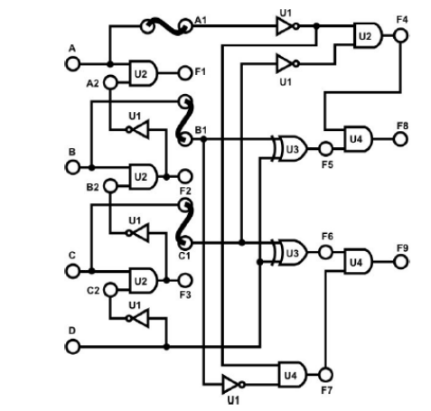

### Fig (9) : 4-to-2-Line Encoder with Basic Gates

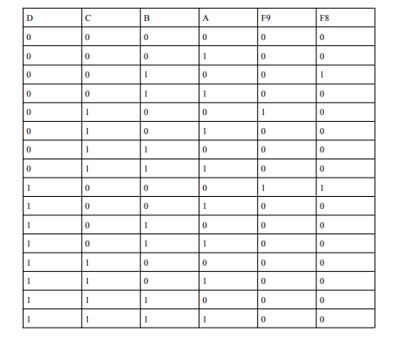

### Truth table (1) : 4-to-2-Line Encoder

## 9-to-4-Line Encoder with TTL IC :

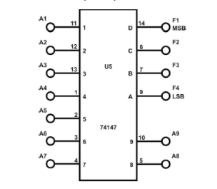

### Fig (10) : 9-to-4-Line Encoder

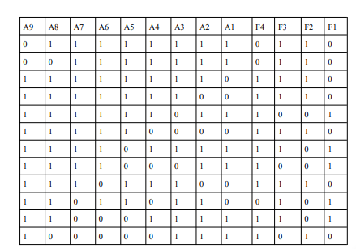

### Truth table (2) : 9-to-4-Line Encoder .

*) Active low input and output

## 2-to-4 Line Decoder with Basic Gates :

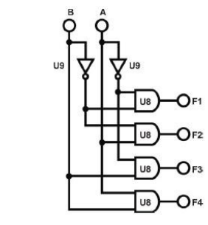

### Fig (11) : 2-to-4 Line Decoder

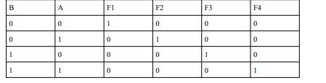

### Truth Table (3) : 2-to-4 Line Decoder

## 4-to-10 Line Decoder with TTL IC :

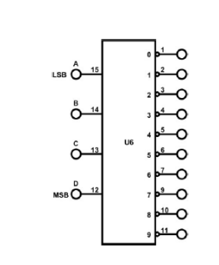

### Fig (12) : 4-to-10 Line Decoder

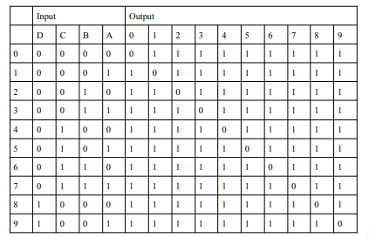

### Truth Table (4) : 4-to-10 Line Decoder

*) Active high inputs / Active low outputs

## 2-to-1 Line Multiplexer with basic Gates :

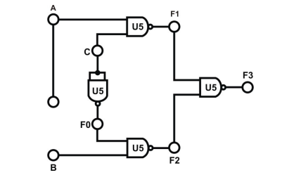

### Fig (13) : 2-to-1 Line Multiplexer

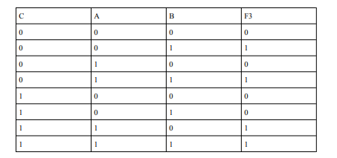

### Truth Table (5) : 2-to-1 Line Multiplexer

Note : we notice that when C = 0 the mux takes the value of input B, but when C = 1 it takes the

value of A and that's how multiplexers work

## 8-to-1 Line Multiplexer with IC :

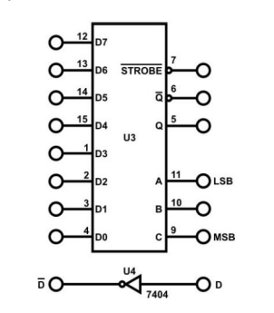

### Fig (14) : 8-to-1 Line Multiplexer.

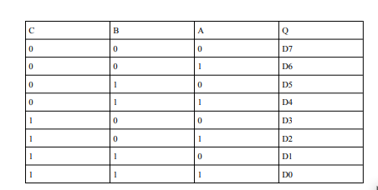

### Truth Table (6) : 8-to-1 Line Multiplexer with IC

*) Active low

## Given the following function:

### F(A, B, C, D)=Σ(0,2,4,5,7,8,10,11,15)

Implementation :

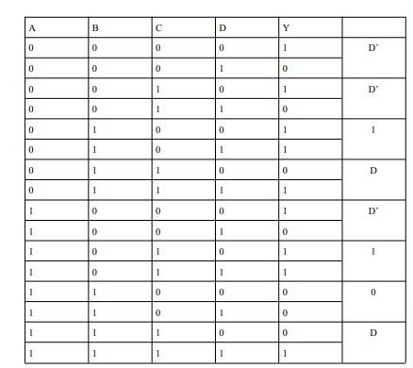

### Truth Table (7) : 3.7 function implementation

## 1-to-8-Line Demultiplexer with CMOSIC :

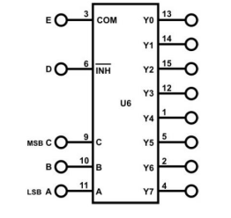

### Fig (16) : 1-to-8-Line Demultiplexer with CMOSIC

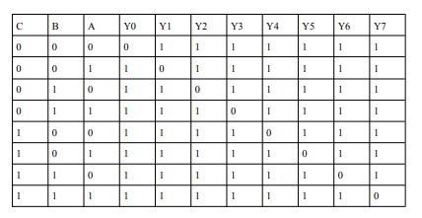

### Truth Table (8) : 1-to-8-Line Demultiplexer.

*) Outputs are in active low mode.

# Conclusion :

In conclusion, this experiment provided a new meaning for ICs for me, like we can know if the ic

is working or not from the behavior of its outputs as in the last procedure the ic output is always

on at the 5th leg (output) with any input, also it defined the use of every combinational circuit we

used (encoders, decoders, mux ,demux) and how we can implement functions using these

circuits.

# References:

● https://www.tutorialspoint.com/digital_circuits/digital_circuits_encoders.htm (10/4/2022

3:41 PM).

● https://www.tutorialspoint.com/digital_circuits/digital_circuits_decoders.htm (10/4/2022

5:08 PM).

● https://www.tutorialspoint.com/digital_circuits/digital_circuits_multiplexers.htm

(10/4/2022 6:41 PM).

● https://www.tutorialspoint.com/digital_circuits/digital_circuits_demultiplexers.htm

(10/4/2022 10:28 PM).

● Digital Electronics and Computer Organization Lab textbook.